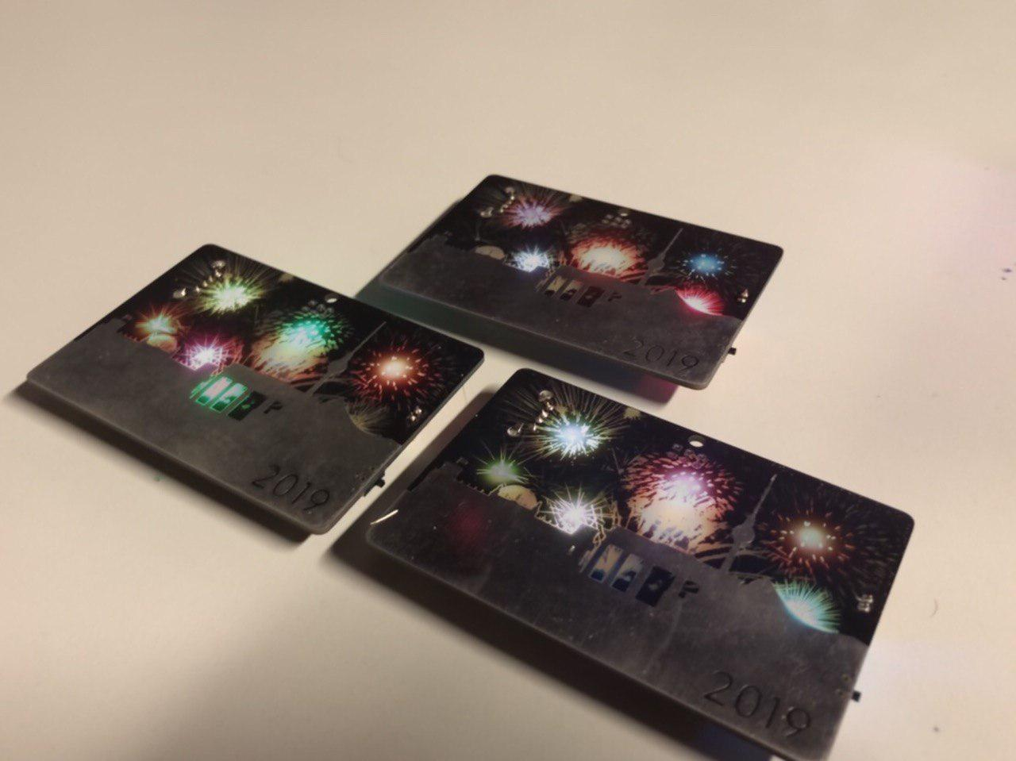

BerlinBadge rev1
Contact: nopx
Projectstatus: 

Summary
Twitterlink zu Video!

Pictures
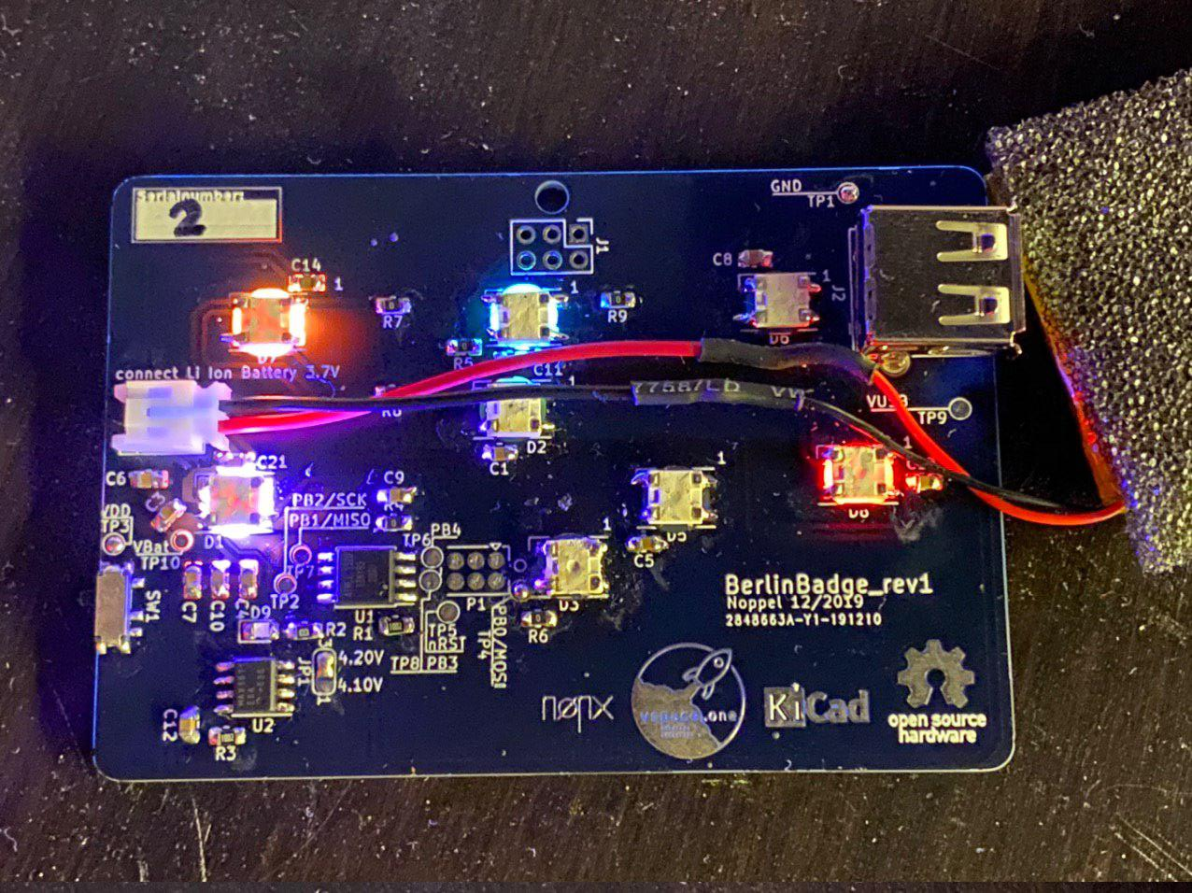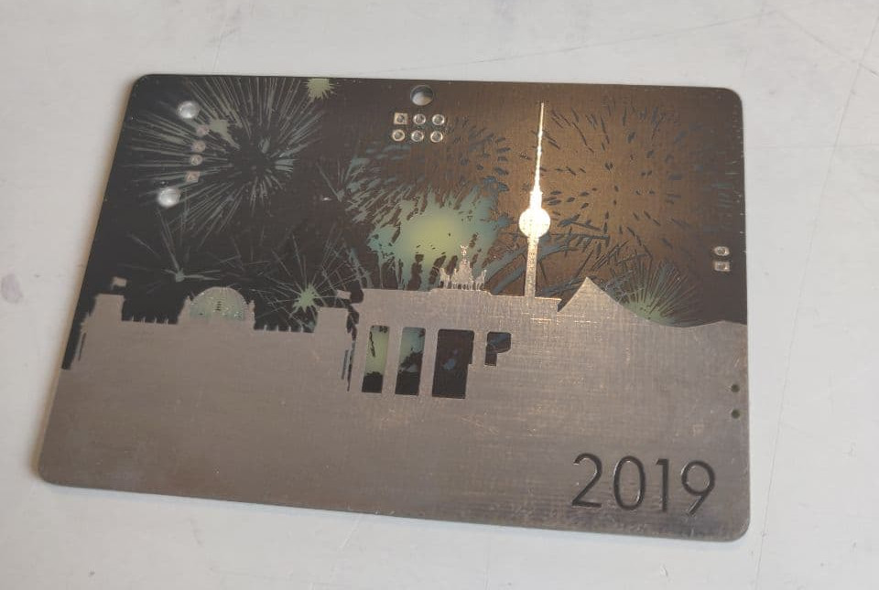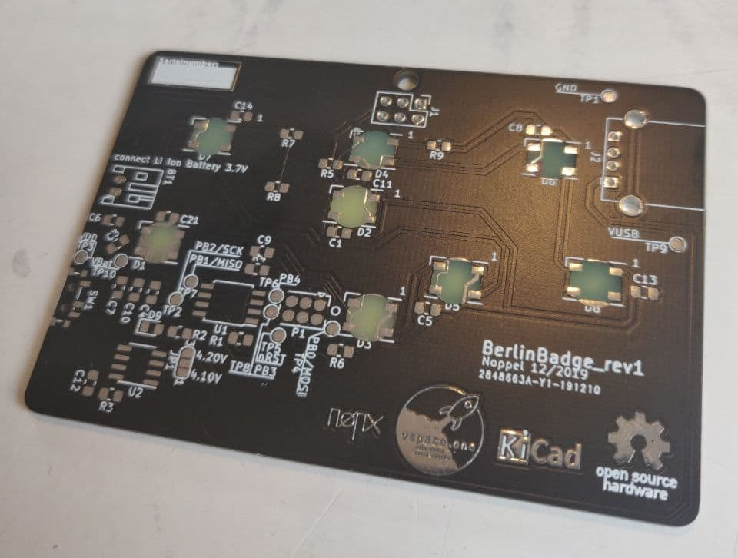

Hardware
Schematic BerlinBadge_rev1

BOM
Label | Qty | Value | Footprint | Description
BT1 | 1 | Connector | JST PH 2.00mm 2-Pins Horizontal
C1, C4, C7, C9, C10, C13, C14 | 7 | 100nF | 0805 C
C2, C3, C5, C6, C8, C11 | 6 | 2.2uF | 0805 C
C12 | 1 | 4.7uF | 0805 C
D1, D2, D3, D4, D5, D6, D7, D8 | 8 | WS2812B | 5050 LED P3.2mm
D9 | 1 | ca. 3V 10mA LED (Yellow) | 0805 LED
J1 | 1 | Connector | 2×3 Odd_Even Pinheader 2.54mm Vertical NOT MOUNTED
J2 | 1 | USB A | USB A Stewart SS52100-001 Horizontal
JP1 | 1 | - | nothing to mount | Solder to match the maximum voltage of the battery
P1 | 1 | - | nothing to mount | AVR ISProgrammer, MaxConnect Link
R1, R3 | 2 | 10K | 0805 R
R2 | 1 | 1K | 0805 R | series resistor for D9, match current!
R4, R5, R6, R7, R8, R9 | 6 | 0R | 0805 R | just for layouting reasons
SW1 | 1 | Switch | SPDT_PCM12 | Example: Amazon Link
U1 | 1 | ATTiny85-20SU | SOIJ-8_5.3×5.3mm P1.27mm | Reichelt ATTINY85-20SU
U2 | 1 | MAX1811 | SOIC-8_3.9×4.9mm P1.27

Software
This is the arduino code running on rev1. You need to install the neopixel lib and compile for Attiny85 with internal 16MHz!
#include <Adafruit_NeoPixel.h>
#ifdef __AVR__
#include <avr/power.h> // Required for 16 MHz Adafruit Trinket
#endif
#define LED_PIN PB1
#define LED_COUNT 8
#define BRIGHTNESS 255
Adafruit_NeoPixel strip(LED_COUNT, LED_PIN, NEO_RGB + NEO_KHZ800);
#define PERCENT_SPAWN 6
struct C{
byte red;
byte green;
byte blue;
};
#define NUM_COLORS 16
C colors[] = {
{0,0,255},
{0,255,0},
{255,0,0},
{0,255,0},
{60,240,0},
{255,255,255},
{10,40,128},
{70,140,10},
{140,70,10},
{12,96,190},
{200,10,80},
{200,80,10},
{80,10,190},
{0,0,255},
};
C leds[LED_COUNT];
C ledsIst[LED_COUNT];
int state[LED_COUNT];
void setup() {
#if defined(__AVR_ATtiny85__) && (F_CPU == 16000000)
clock_prescale_set(clock_div_1);
#endif
strip.begin();
strip.show();
strip.setBrightness(BRIGHTNESS);
for(int i=0; i<strip.numPixels(); i++) {
leds[i].red = 0;
leds[i].blue = 0;
leds[i].green = 0;
}
}
void clearLED(int i){
leds[i].red = 0;
leds[i].blue = 0;
leds[i].green = 0;
}
bool isOut(int i){
return leds[i].red == 0 && leds[i].blue == 0 && leds[i].green == 0;
}
void setLED(int i, C c){
leds[i].red = c.red;
leds[i].blue = c.blue;
leds[i].green = c.green;
state[i] = 1;
}
void dimLED(int i){
if(state[i] == 0){
ledsIst[i].red = 0;
ledsIst[i].green = 0;
ledsIst[i].blue = 0;
return;
}
if(state[i] == 4){
ledsIst[i].red = int(leds[i].red);
ledsIst[i].blue = int(leds[i].blue);
ledsIst[i].green = int(leds[i].green);
}else if(state[i] > 4){
int f = ((state[i]-4)*2);
ledsIst[i].red = int(leds[i].red / f);
ledsIst[i].blue = int(leds[i].blue / f);
ledsIst[i].green = int(leds[i].green / f);
}else if(state[i] < 4){
int f = ((4-state[i])*2);
ledsIst[i].red = int(leds[i].red / f);
ledsIst[i].blue = int(leds[i].blue / f);
ledsIst[i].green = int(leds[i].green / f);
}
state[i]++;
if(state[i] == 15){
state[i] = 0;
}
}
void loop() {
for(int i=0; i<strip.numPixels(); i++) {
if( random(0,100) < PERCENT_SPAWN && state[i]==0){
C col = colors[random(0,NUM_COLORS)];
setLED(i,col);
}
dimLED(i);
}
for(int i=0; i<strip.numPixels(); i++) {
C col = ledsIst[i];
strip.setPixelColor(i, col.red, col.green, col.blue);
}
strip.show();
delay(70);
}

