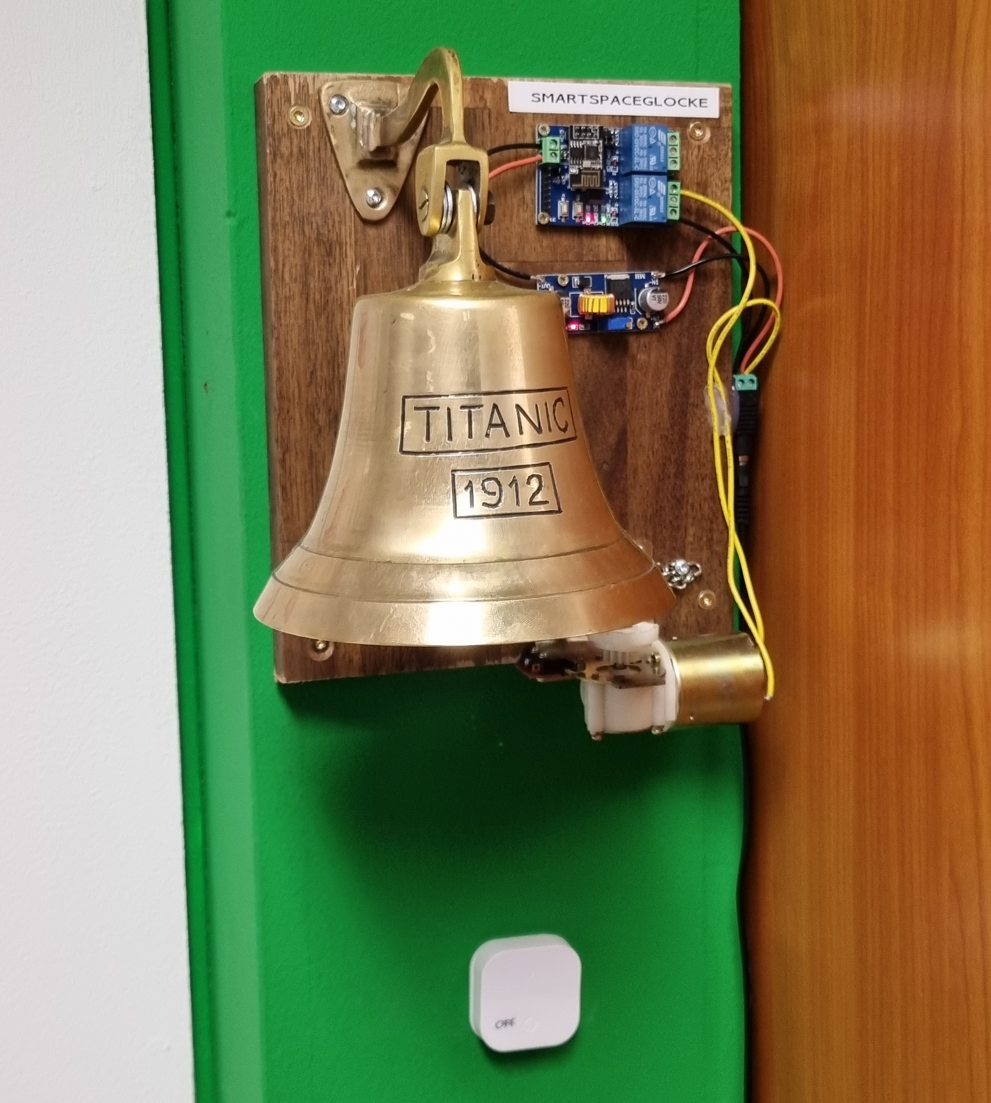

Smart Space Glocke
Contact: Nikolai, Kai
Projectstatus: Aufgebaut und Einsatzbereit

Video
smartspaceglockevid.mp4

Bauteile
- ESP Relay Board zb https://www.aliexpress.com/item/1005002147923725.html
- LM2596S Stepdown für 5V
- Gespendete Glocke
- 15V Motor mit Getriebe aus der Fundkiste
- Beliebiges 15V Netzteil

ESPHome Config
esphome:
name: spaceglocke
esp8266:
board: esp01
# Enable logging
logger:
baud_rate: 0 #need this to free up UART pins
# Enable Home Assistant API
api:
password: ""
# Example configuration entry
web_server:
port: 80
ota:
password: ""
wifi:
ssid: "vspace.one"
password: "XXX"
uart:
baud_rate: 115200 # speed to STC15L101EW
tx_pin: GPIO1
rx_pin: GPIO3
switch:
- platform: uart
name: "A1on"
data: [0xA0, 0x01, 0x01, 0xA2]
- platform: uart
name: "A1off"
data: [0xA0, 0x01, 0x00, 0xA1]
- platform: uart
name: "A2on"
data: [0xA0, 0x02, 0x01, 0xA3]
- platform: uart
name: "A2off"
data: [0xA0, 0x02, 0x00, 0xA2]
- platform: restart
name: "2switch_a Restart"

Notizen

