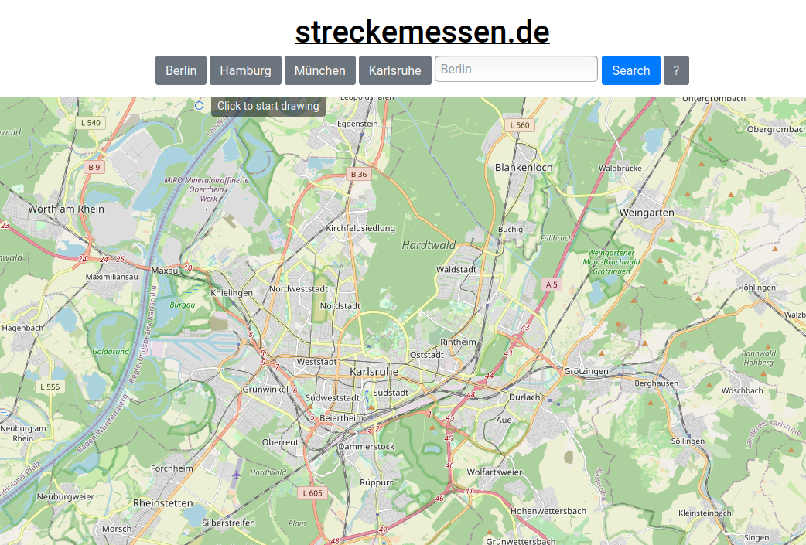

Streckemessen.de
Contact: nopx
Projectstatus: 
Please find it here: https://streckemessen.de/
Please find the sourcecode here: https://github.com/noppelmax/streckemessen.de

