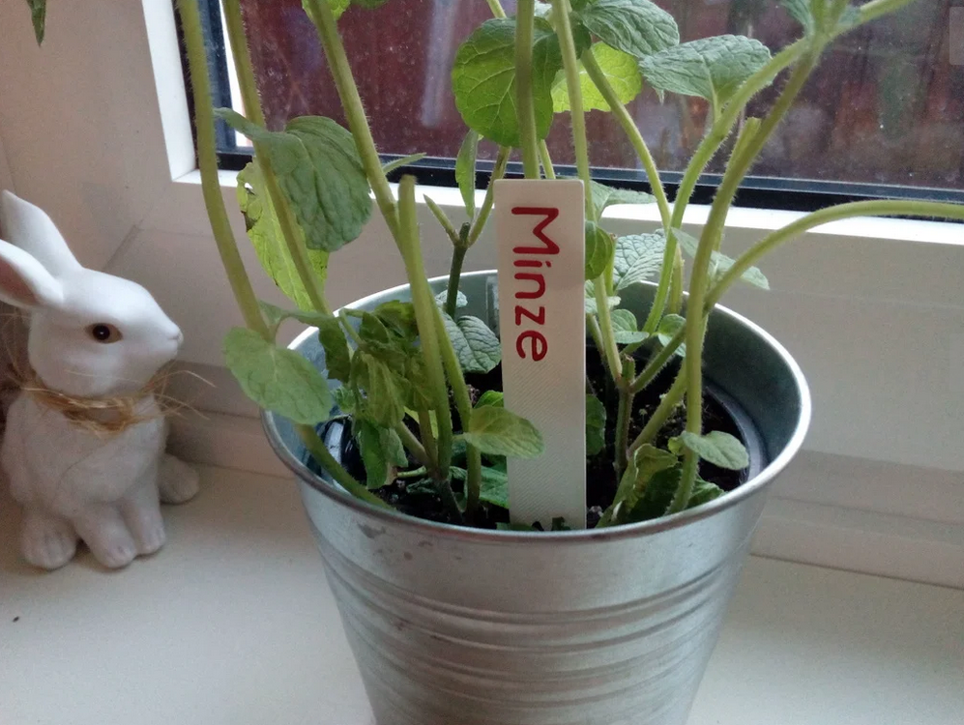

Plant Signs
Contact: nopx
Projectstatus: 
Please find this project here: https://www.thingiverse.com/thing:3555417

