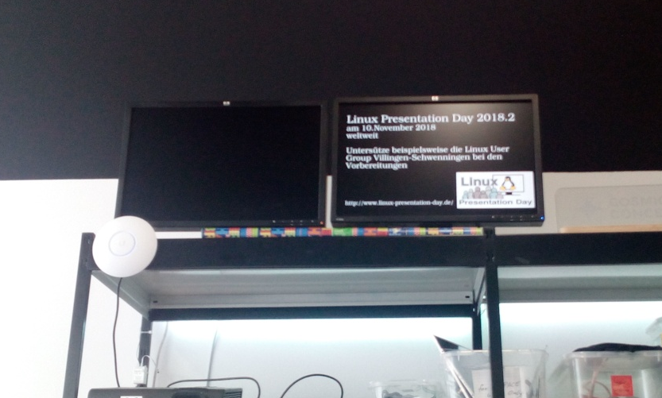

<del>Spaceinfo</del>
Contact: nopx
Projectstatus: retired
Please find further information here: https://github.com/vspaceone/spaceinfo
New-and-worsened version: projekte:2022:spaceinfo-shitty

