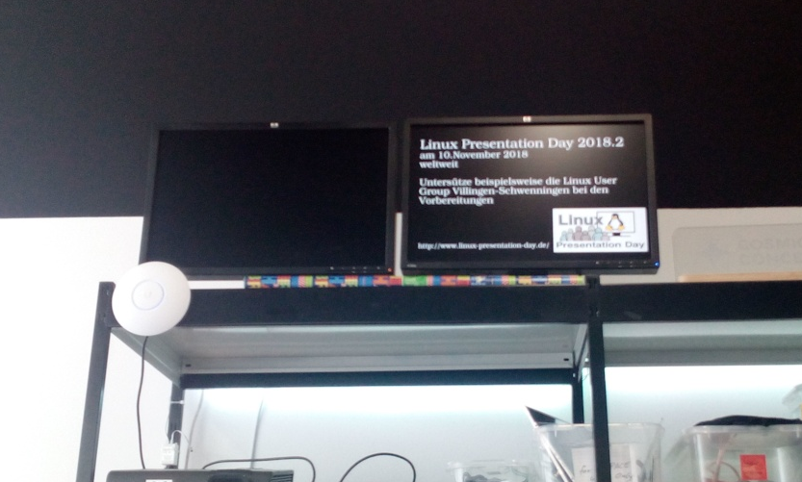

Spaceinfo
Contact: nopx
Projectstatus: 
Please find further information here: https://github.com/vspaceone/spaceinfo
New-and-worsened version: projekte:2022:spaceinfo-shitty

