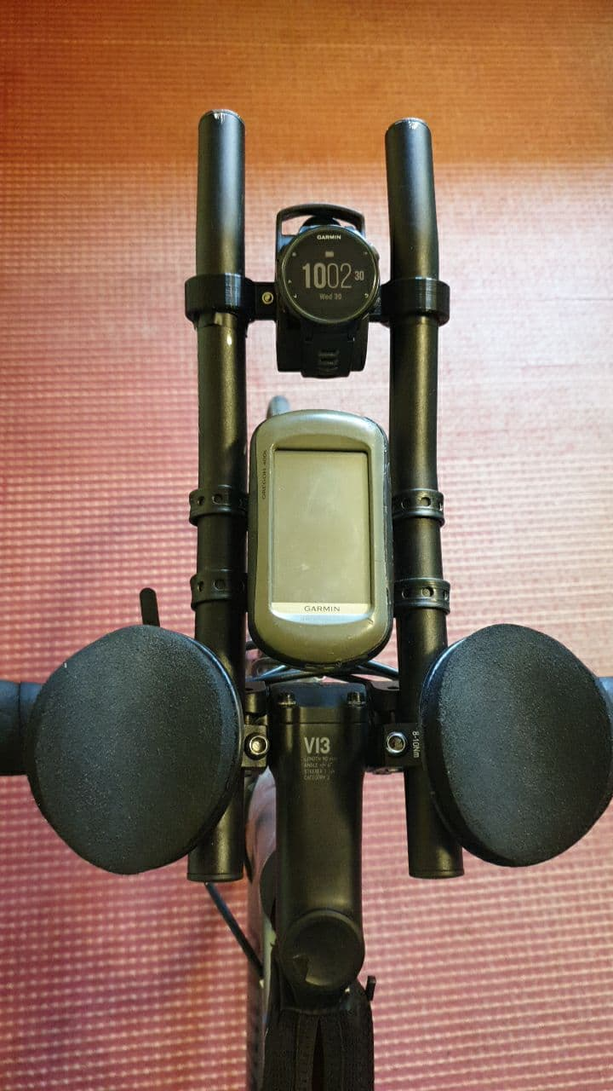Cockpitview

Fahrradhalterung
Contact: nopx
Projectstatus: 

Summary
A friend needed a part to mount his watch at the bike. So i decided to just print it. Worked fine!

Pictures
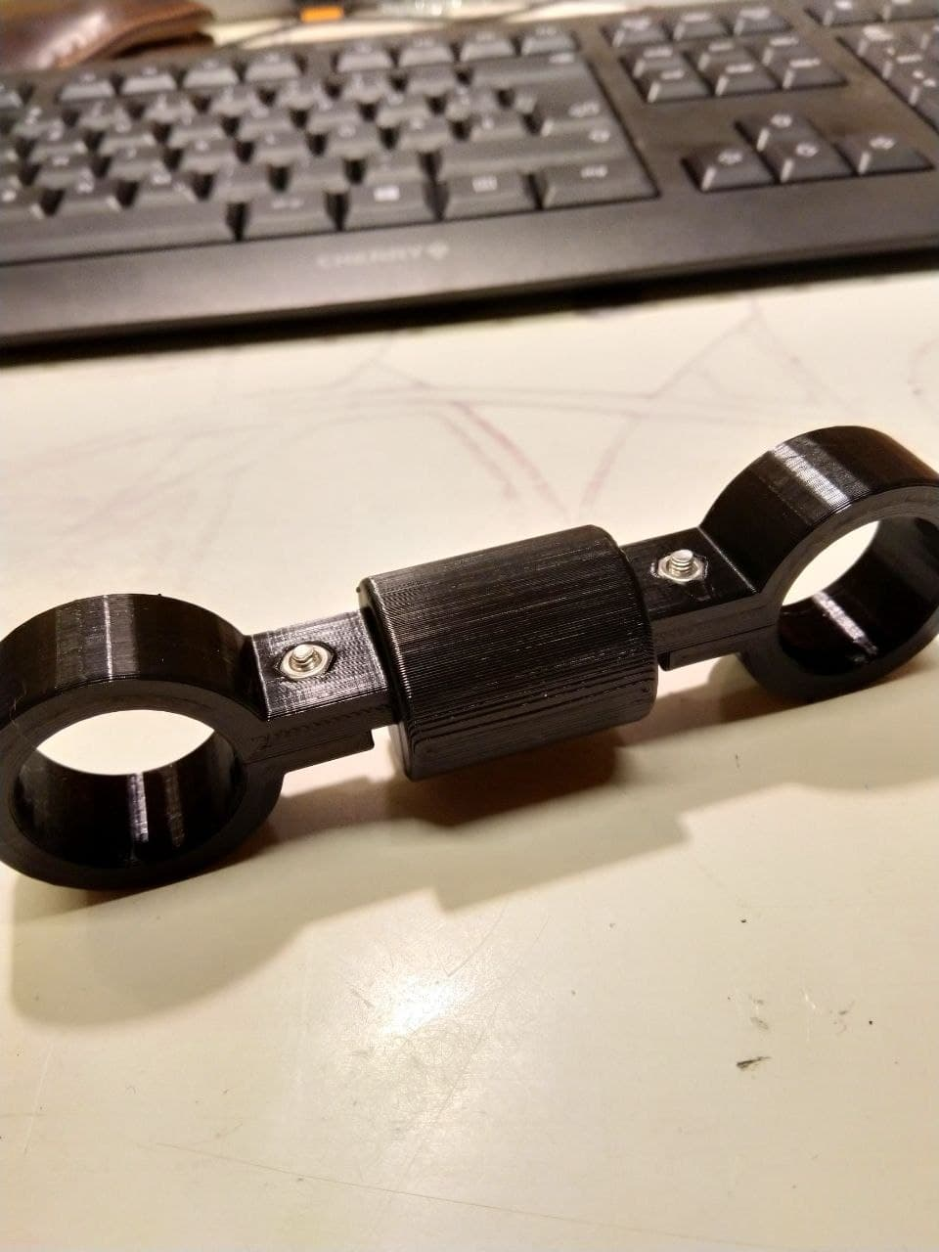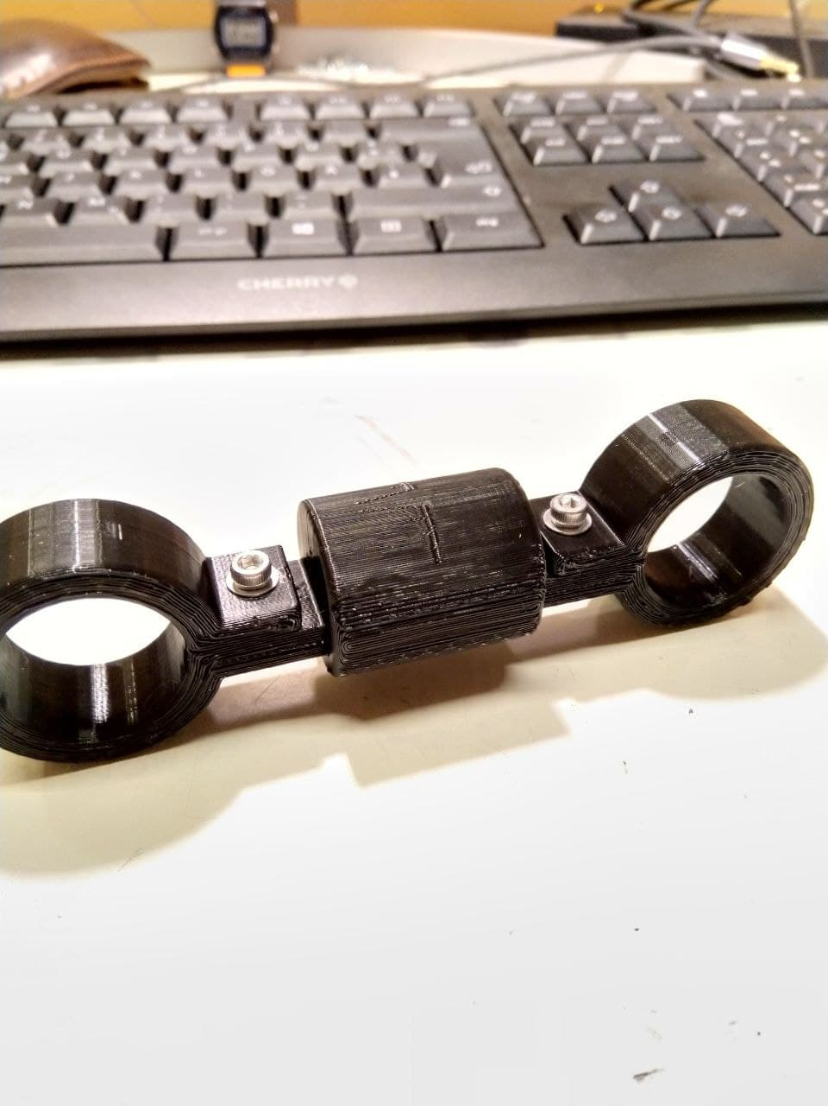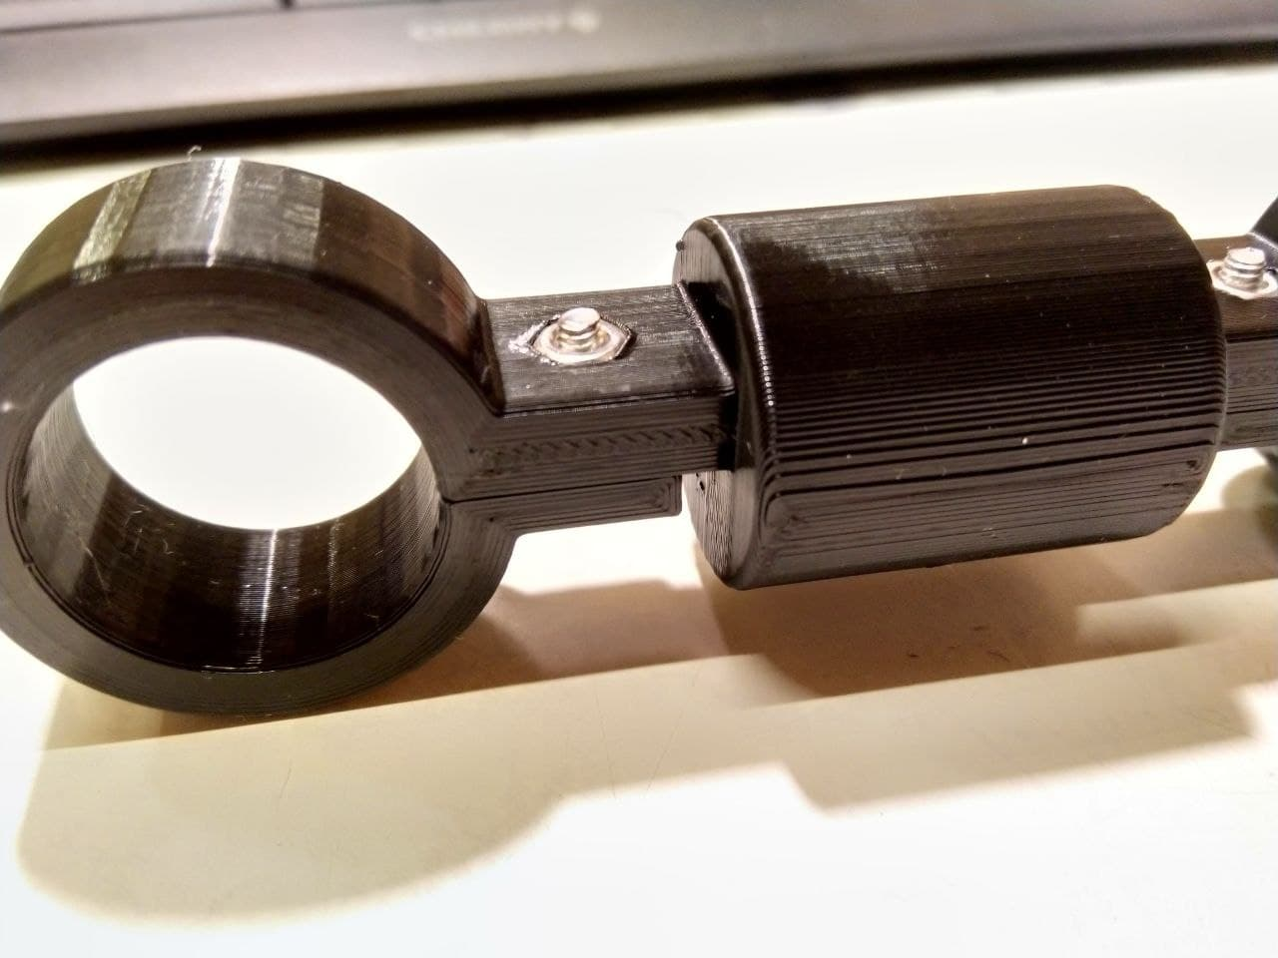
~~DISCUSSION~~

