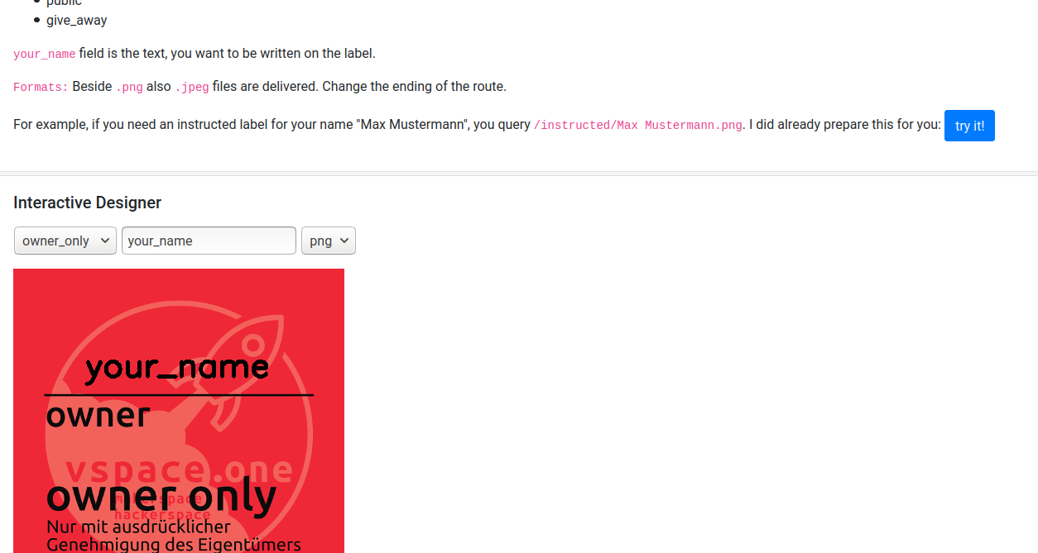

LabelGenerator
Contact: nopx
Projectstatus: 
Please find it hosted here: http://labelgenerator.vspace.one/
Please find the repo here: https://github.com/vspaceone/LabelGenerator

