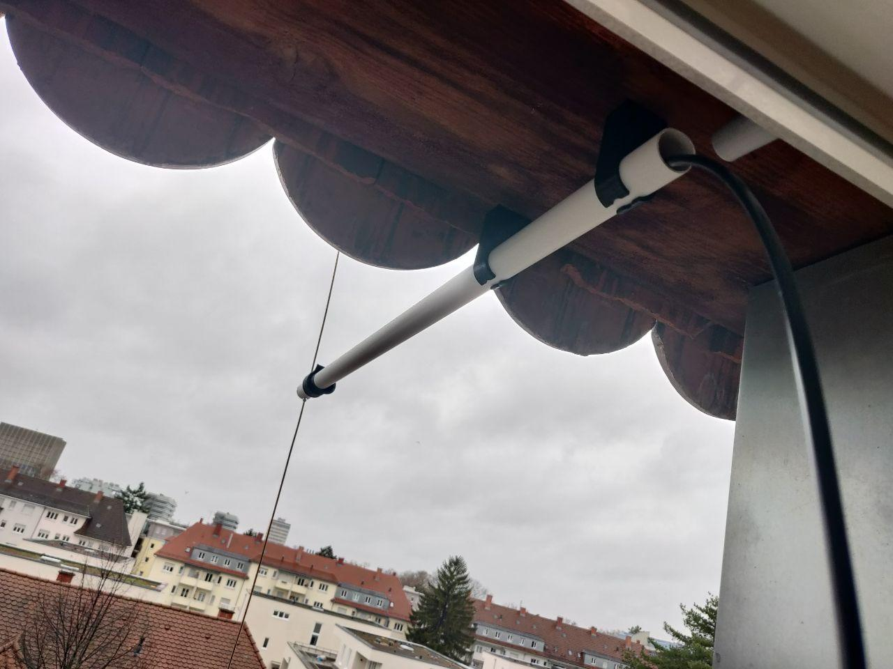

MX-1 Antenna (2m Band)
Contact: nopx
Projectstatus: (Nov 2021)

Remark
This antenna has several disadvantages. First, having a large surface seems to be suboptimal for antenna. Hence using pipes would have been better. Secondly the mechanical solution at the tip is nice but does not involve a balun, which is preferable for dipole antennas. Overall i suggest to rework the general idea of this antenna for the next time. Still i'm using it sometimes as station antenna at home when doing VHF at high-power mode. My Yaesu FT-something handheld is only making 5 watts. The biggest disadvantage is that it does not have plug for coaxial cables but is directly attached to the wire. I could find any nice solution to this.

Project Goals

Material
Desc | Qty
PCV pipe | 1
3d printed cap | 2
Coaxial Wire | > 2m
Distance Holders M3x5mm | 2
Poles M3 | ~2m

Assembly

Files
The files are available on thingiverse: https://www.thingiverse.com/thing:5155664

Photos


