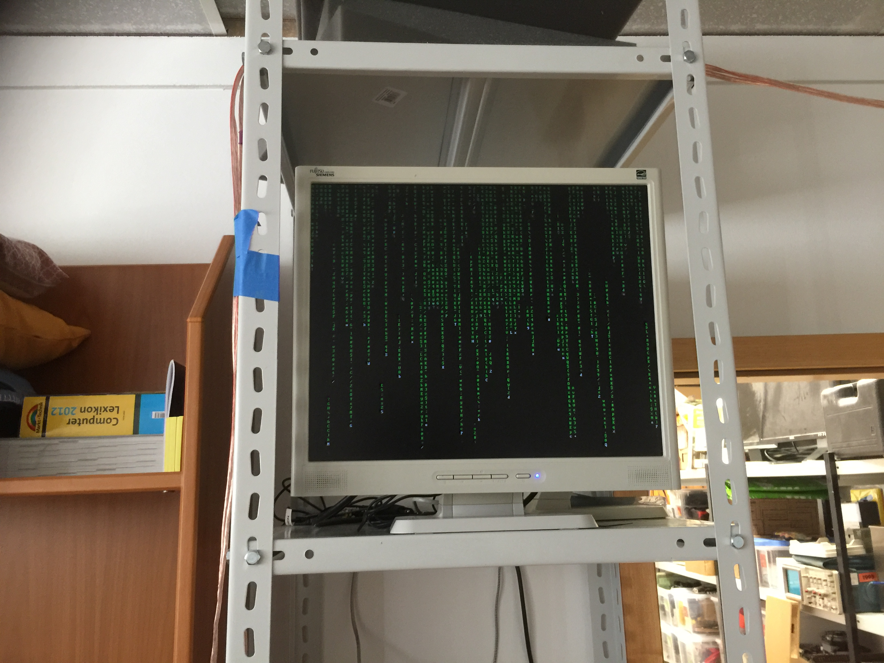

<del>Spaceinfo 2: Electric boogaloo</del>
Contact: H3
Projectstatus: half-working retired
The new-space version of nopx's Spaceinfo project. Currently maintained by H3, but anyone is allowed to fix things.
Right now it consists of 2 monitors (may be upgraded to 4 in the future as there are 2 more of the same model), one facing the couch area running pixelflut on a modified version of pixelnuke until PR #22 gets merged into the original, and one facing more in the direction of the door, running in kiosk mode displaying the spaceinfo screens via spaceinfo.vspace.one, a soon-to-be-set-up server by nopx. Both are powered by two seperate Raspberry Pi 1B (still very slow). The internet connection is made by a permanent tempoary ethernet wire taped to the cieling. To switch the monitors on and off with the space status and to do other things, some of the spaceinfo-scripts are installed on both PIs.
All current todos are in the /etc/motd of the respective pi

