Info Tiles
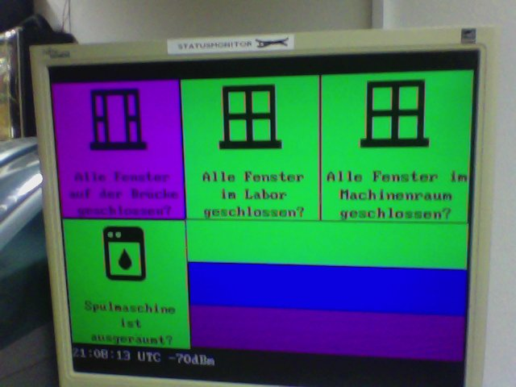
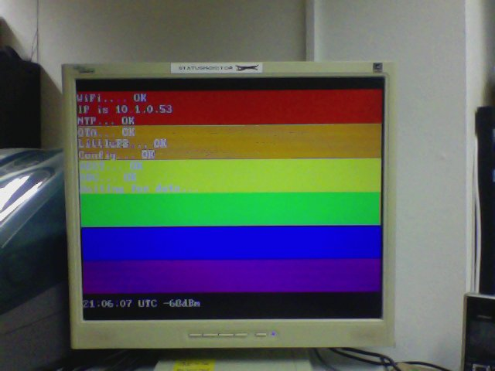
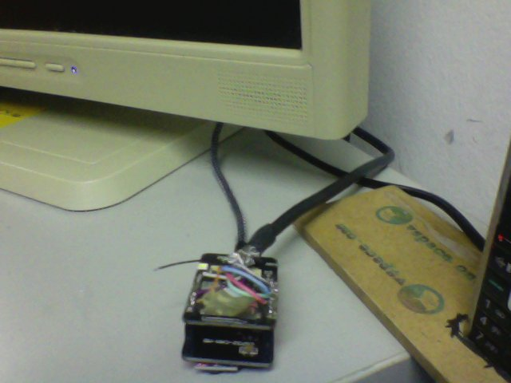
Contact: H3
Status: 
Ownership:

documentation
Souce Code & Docs are on the projects GitHub page: https://github.com/vspaceone/esp32_info_tiles.

current config.h
const char* wifi_ssid = "vspace.one";
const char* wifi_pass = "12345678";
const char * ota_pass = "CHANGE_ME_please";
//#define COLOR_BARS
//#define TRANS_FLAG
#define LGBTQ_FLAG
const char * hostname = "tiles.int.vspace.one";
#define USE_STATIC_IP
IPAddress static_ip(10,1,0,53);
IPAddress gateway(10,0,0,1);
IPAddress subnet(255,0,0,0);
IPAddress dns1(10,0,0,1);
IPAddress dns2(1,1,1,1);

