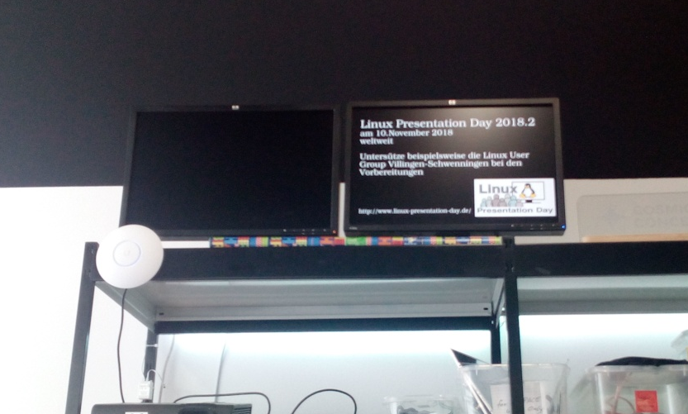

Spaceinfo
Contact: nopx
Projectstatus: 
Please find further information here: https://github.com/vspaceone/spaceinfo

