XML T6 Mod
Contact: nopx
Projectstatus: 

Summary
My XML T6 flashlight got some crazy modes, like strobe, sos. I don't need that on my bike. So I decided to disable them. After disassembling the flashlight and searching for the transistor datasheet, I found this page: XML T6 Mod. Someone else already did the same thing. After checking the datasheet of the LED I decided to assemble the mod without further research.
- Datasheet LED
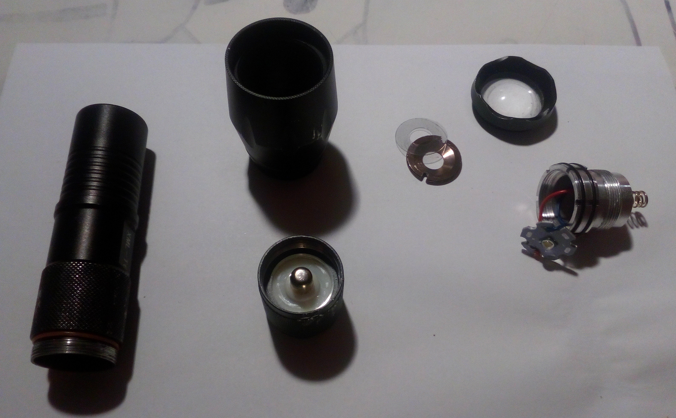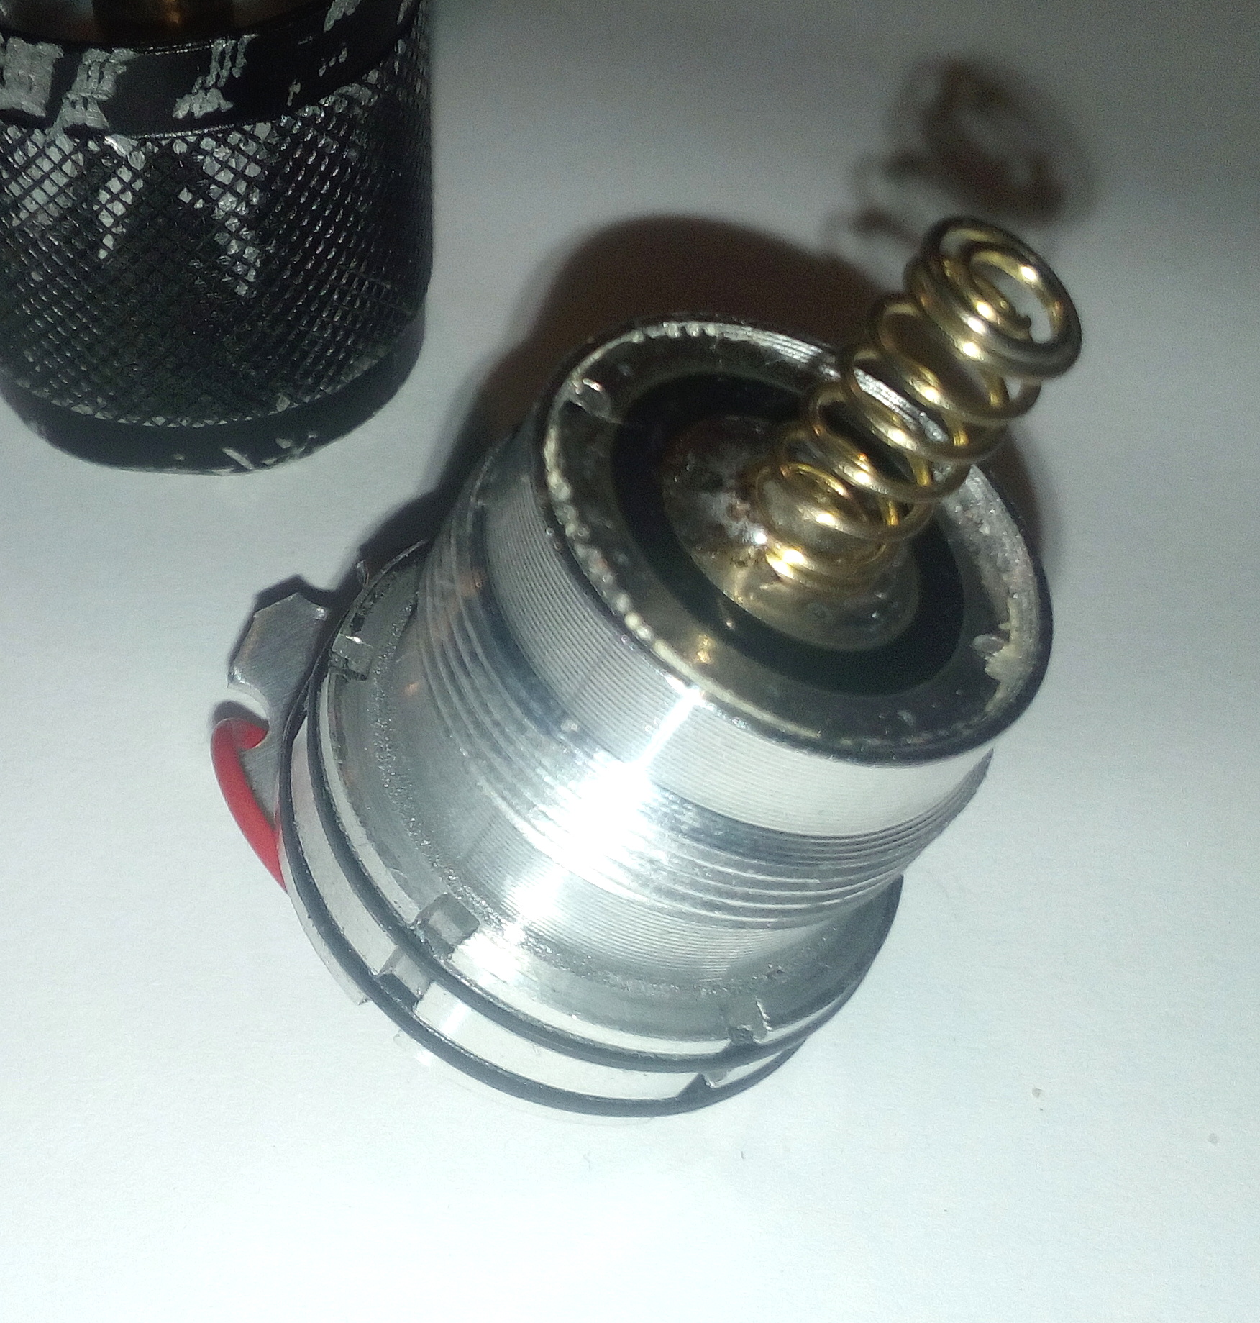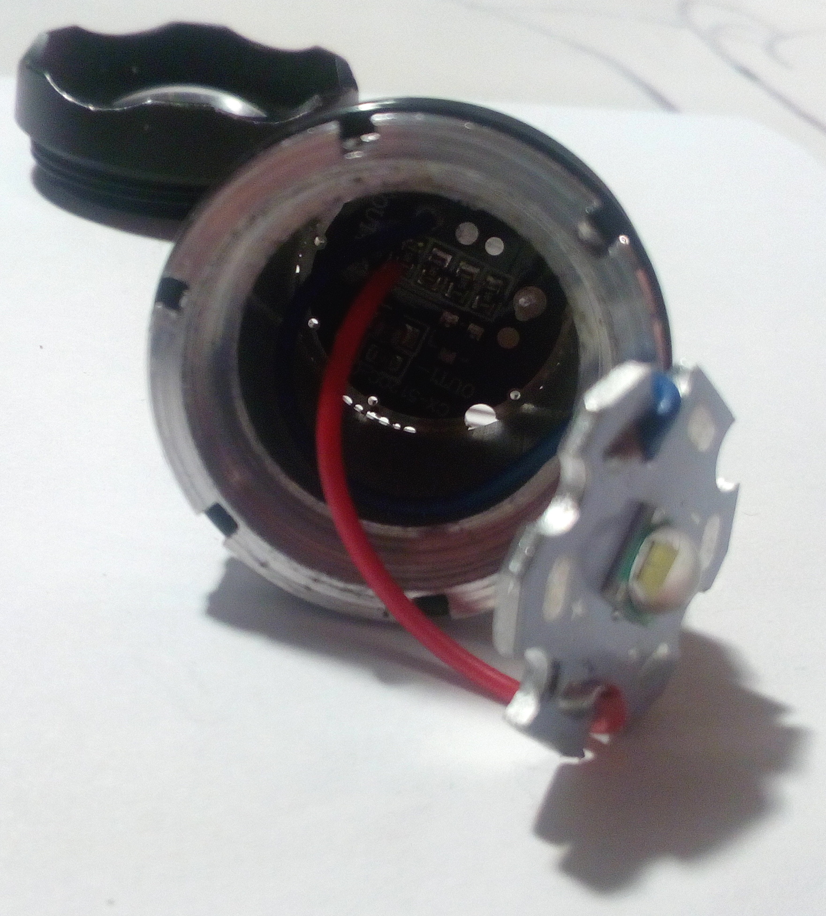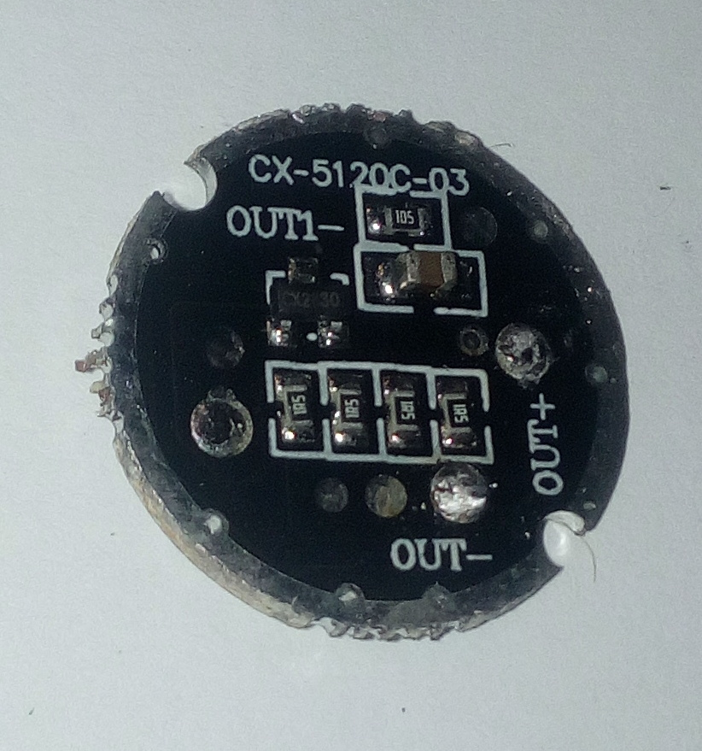
Just connect those two pads. Additionally I replaced the two wires to the LED just in case. The current is greater now, then before.


