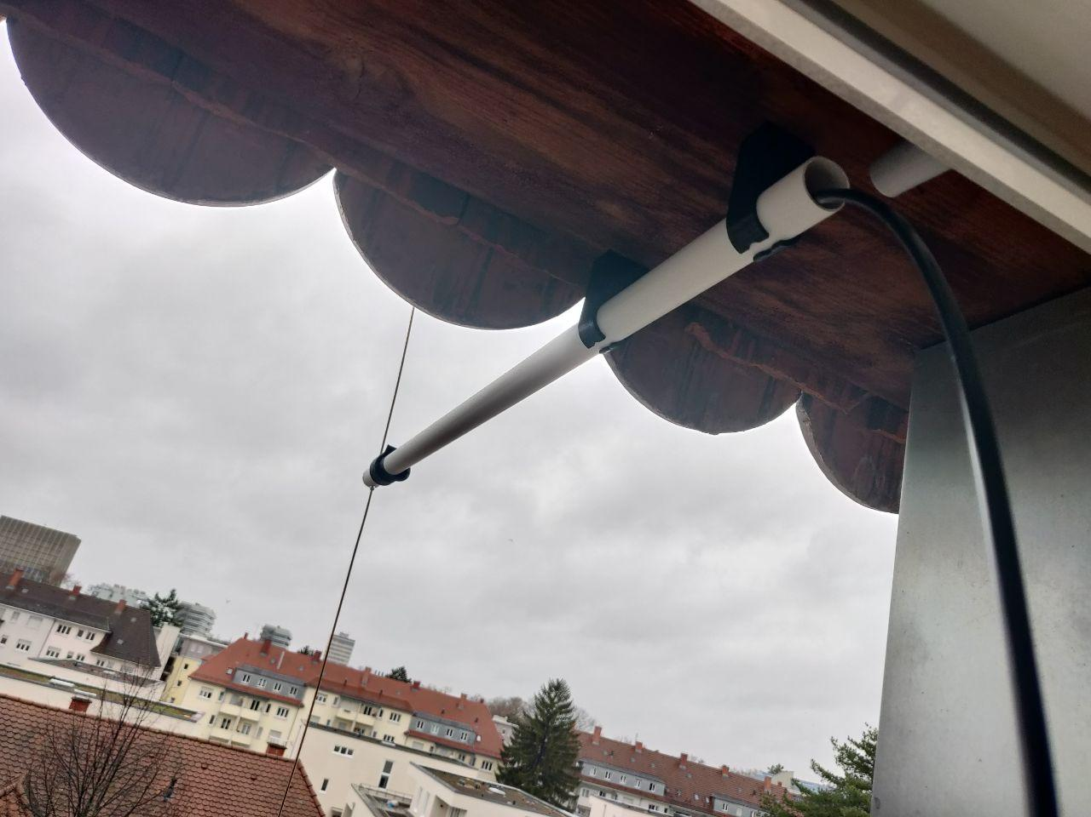

MX-1 Antenna (2m Band)
Contact: nopx
Projectstatus: (Nov 2021)

Project Goals

Material

Assembly

Files
The files are available on thingiverse: https://www.thingiverse.com/thing:5155664

Photos


